**Carbon Table 3–Tracking progress toward carbon negative by 2030**

In FY23, we procured 5.015 million metrics tons of carbon removals. Carbon removal contracted each year includes credits retired in the same year and to be retired in future years, in support of our annual in-year carbon neutrality and 2030 carbon negative targets.

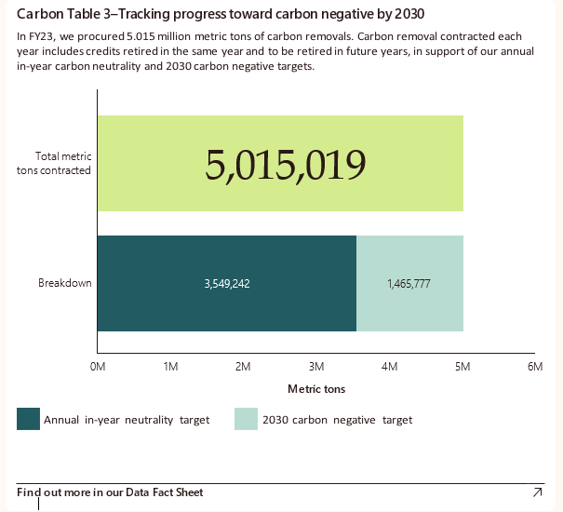

Bar graph showing the progress toward carbon negative by 2030. The x-axis represents 0 to 6 metric tons and the y-axis represents Total metric tons contracted that is 5,015,019 Metric tons and Breakdown that includes 3,549,242 Metric tons of Annual in-year neutrality target and 1,465,777 Metric tons of 2030 carbon negative target.